Contents

Open Software Tool in Visual Studio 2

Example Data 5

Perform Turnover Accuracy Test (Events Compare) 5

Perform Occupancy Accuracy Test (Occupancy Compare) 7

Display parking records and charts 8

The software was built for a truck parking detection technology evaluation project, it is not robust, and can only load .csv data files and perform accuracy tests that are specific to the project. Following are specific steps to perform the functions of the software tool (note that not following the steps may cause malfunctions of the software). Example data files are provided in the Example Data folder.

## Open Software Tool in Visual Studio

1. GitHub clone

Click “Clone or download” in the GitHub page, and then choose to “Open in Visual Studio”. Note that in order to have this option, you should have already installed Visual Studio and GitHub Extension for Visual Studio and logged in your GitHub account in the Visual Studio.

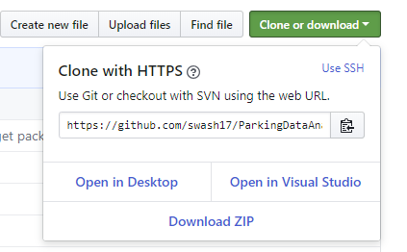

1. Clone to local Git repository

After launching Visual Studio, it will ask you to select a local folder to clone the software code to local Git repository.

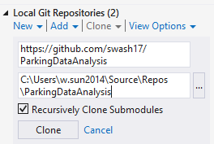

After cloning, double click that repository and the software solution will show up.

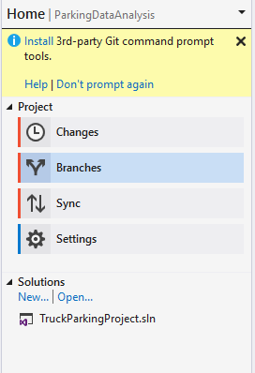

1. Check out code in Solution Explore

The code of the software can be found in Solution Explore.

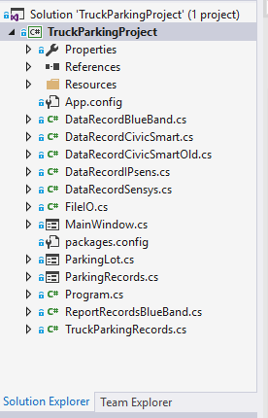

Click References, if the SwashStatistics_ChartingControl is not referenced correctly, go to the next step.

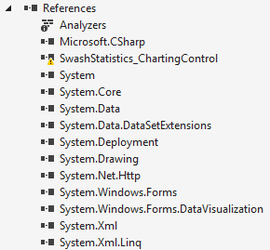

1. Reference NuGet package

In “Tools”, choose “NuGet Package Manager”, and then “Manage NuGet Packages for Solution”.

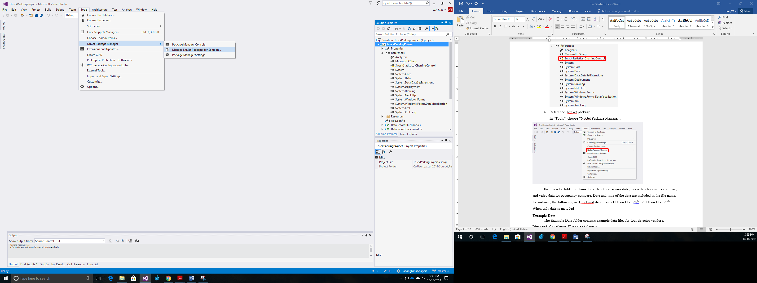

Click “Restore” in the right corner, and then the NuGet package will be referenced correctly.

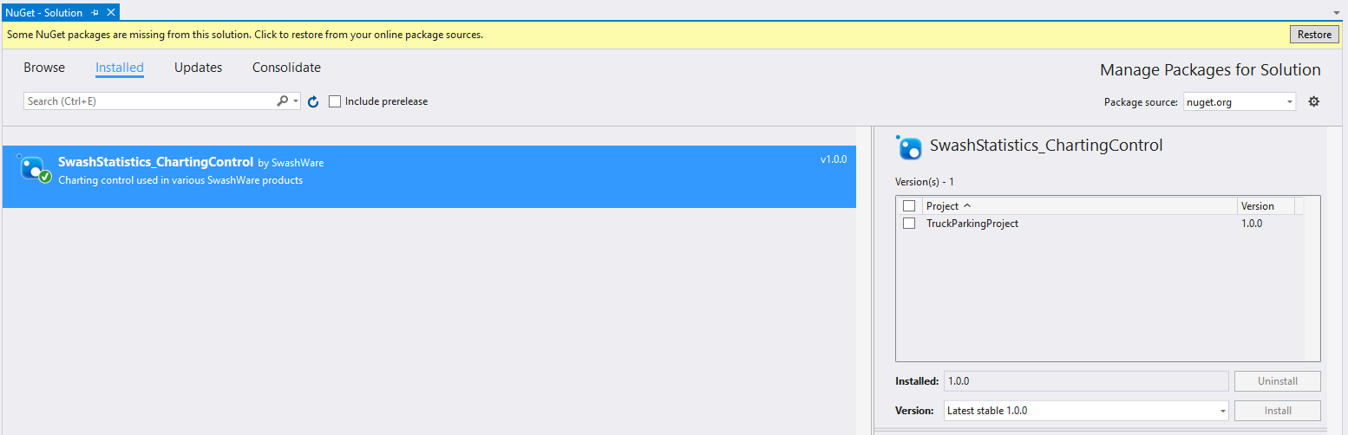

1. Click “Start” to run the software.

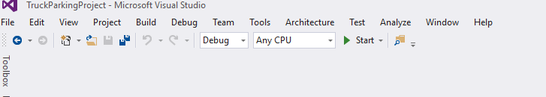

## Example Data

The Example Data folder contains example data files for four detector vendors: BB (Blueband), CS (CivicSmart), IP (IPsens), and SS (Sensys).

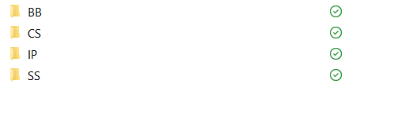

Each vendor folder contains three data files: sensor data, video data for events compare, and video data for occupancy compare. Date and time of the data are included in the file name, for instance, the following are BlueBand data from 21:00 on Dec. 28th to 9:00 on Dec. 29th. When only date is included in the name, it means the file contains data of the whole day (0:00 to 23:59).

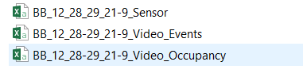

## Perform Turnover Accuracy Test (Events Compare)

1. Load video data file

Load video data for events compare in the main screen.

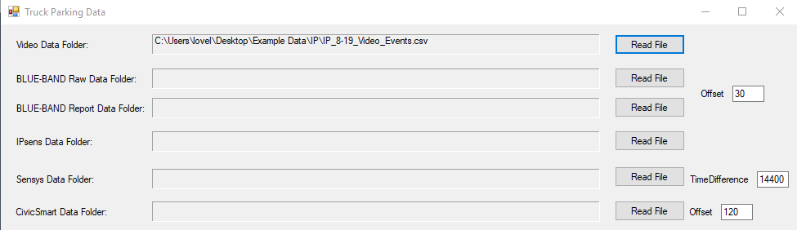

1. Load sensor data file

Load sensor data in the main screen.

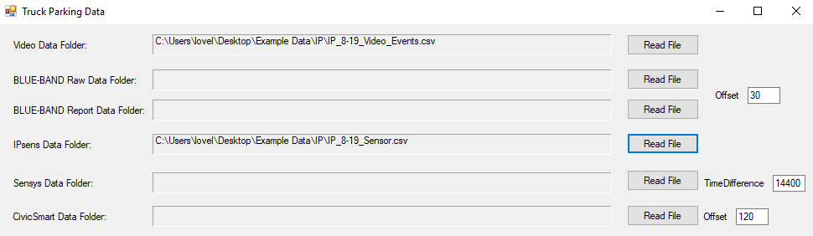

1. Specify record interval

Specify the record start date and time, as well as end date and time.

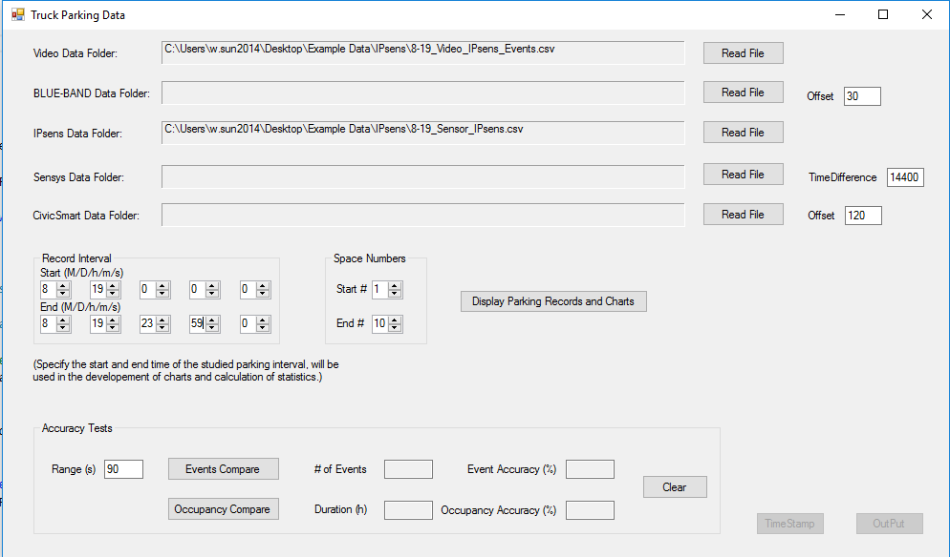

1. Specify space numbers

Specify the parking space numbers. For CivicSmart, the space numbers should start with 11 and end with 20; for the other vendors, the space numbers start from 1 and end with 10.



1. Conduct turnover accuracy test

Specify the range of errors in seconds, default is $±$ 90 seconds.

Click “Events Compare” and the results will show up instantly.

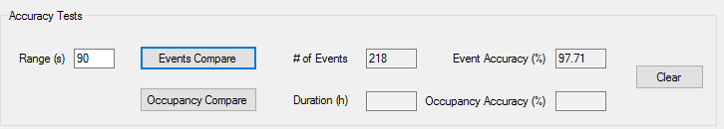

## Perform Occupancy Accuracy Test (Occupancy Compare)

1. Load video data file

Load video data for occupancy compare in the main screen.

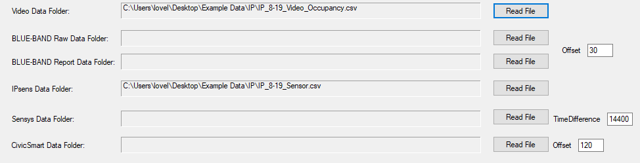

1. Load sensor data file

Load sensor data in the main screen (load the data file again even if it was loaded before in the event compare).

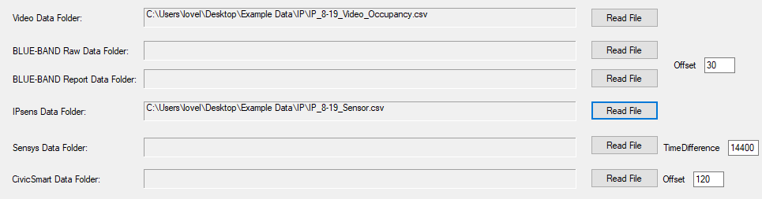

1. Specify record interval

Specify the record start date and time, as well as end date and time.



1. Specify space numbers

Specify the parking space numbers. For CivicSmart, the space numbers should start with 11 and end with 20; for the other vendors, the space numbers start from 1 and end with 10.



1. Conduct occupancy accuracy test

Click “Occupancy Compare” and the results will show up. (Sometimes it may take a few seconds for the occupancy accuracy test to complete.)

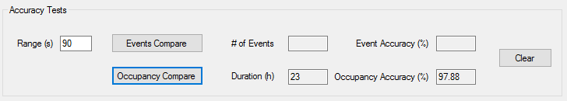

## Display parking records and charts

1. Load IPsens video data file

Load video data for IPsens events compare in the main screen. (Note that this function only works with IPsens data right now)

1. Display records and charts

Click “Display Parking Records and Charts” button and a separate form will show up.

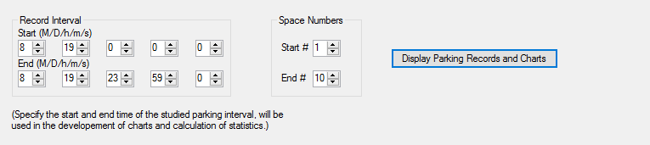

1. Record list

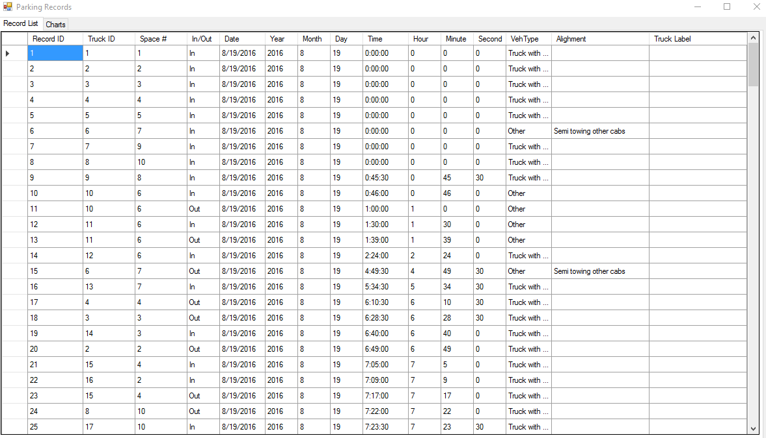

1. Chart

Four types of charts are included.

*Exact Time Chart*

Specify the date and time and then click “Display Chart”, the occupancy status of the 10 parking spaces at the specified time will show up in the chart. (Note that sometimes the “Statistics” in the left corner does not function correctly, ignore that please)

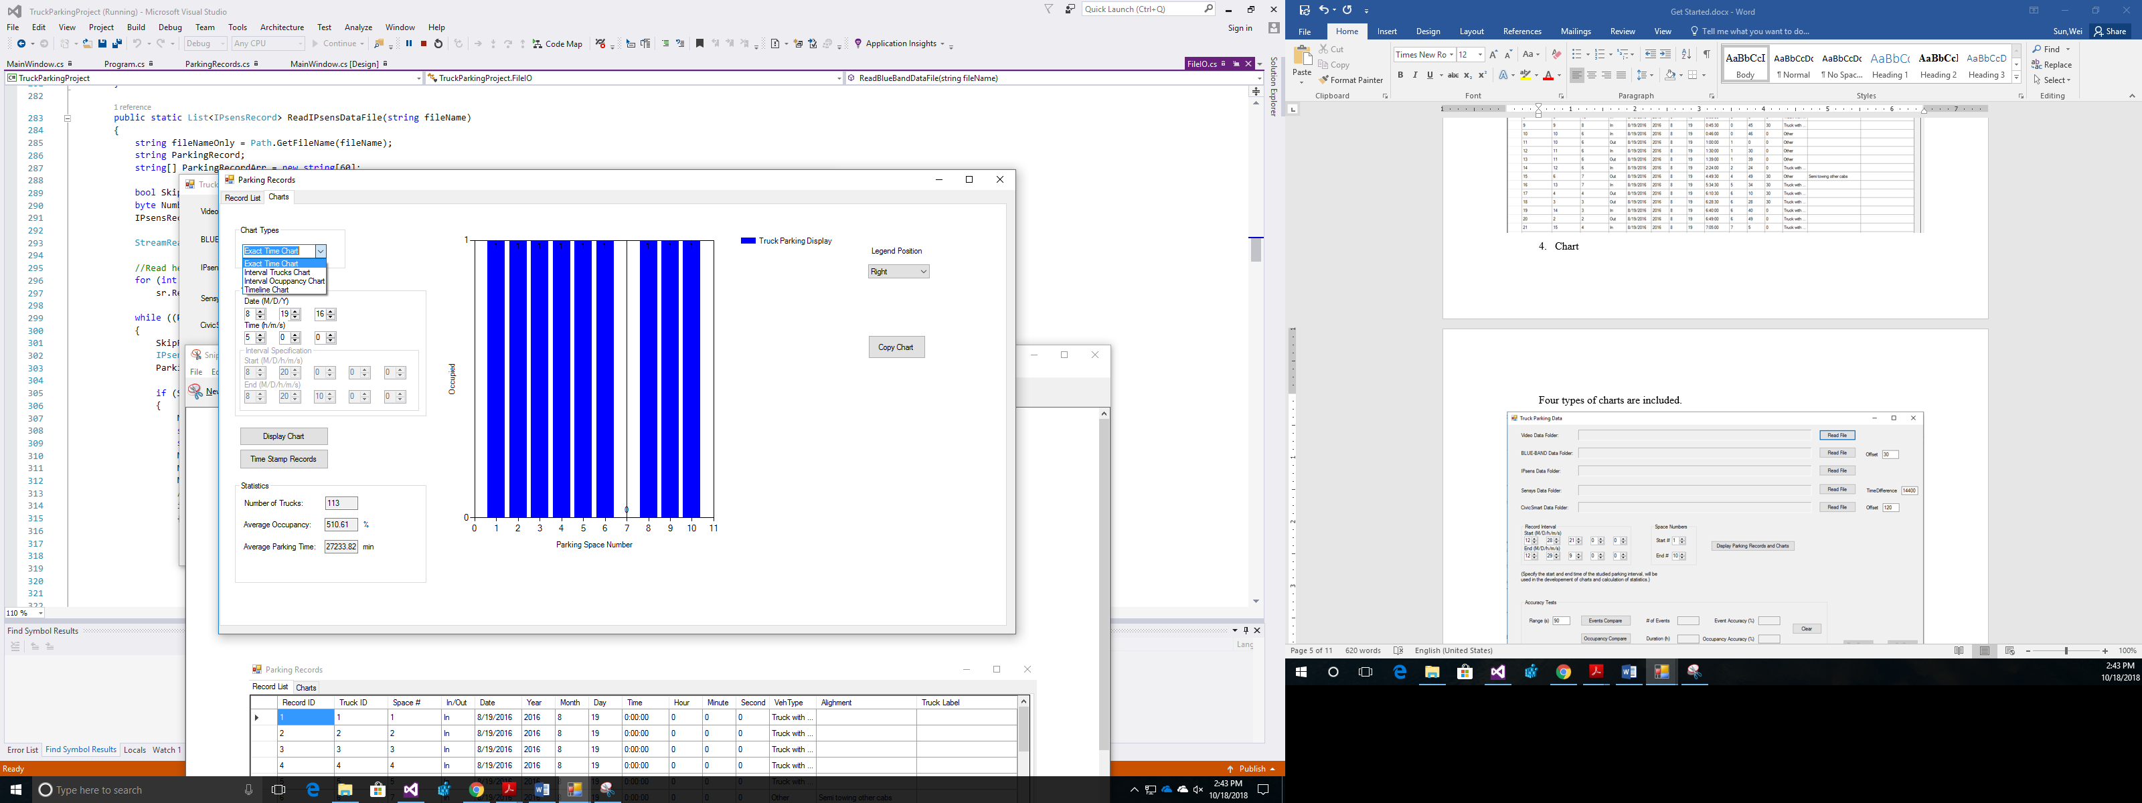

*Interval Trucks Chart*

Specify the date and time interval and then click “Display Chart”, the number of trucks parked at each parking space during the interval will show up in the chart.

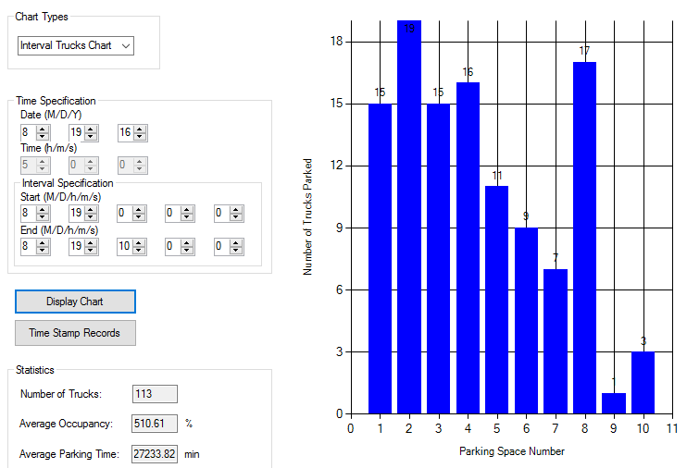

*Interval Occupancy Chart*

Specify the date and time interval and then click “Display Chart”, the occupancy rate of each parking space during the interval will show up in the chart. (for instance, the value of the first column is 63.95%, meaning parking space 1 was occupied 63.95% of the interval)

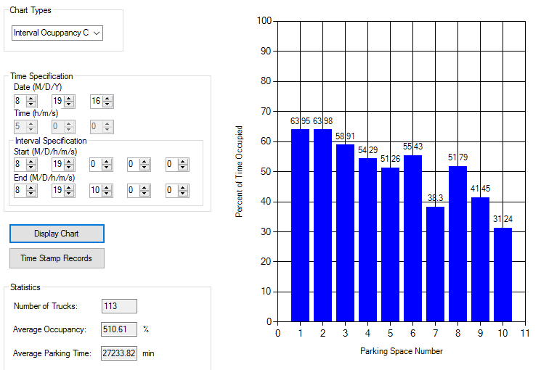

*Timeline Chart*

Specify the date and then click “Display Chart”, the occupancy status timeline for each parking space will show up, blue line indicating the time parking space was occupied.

